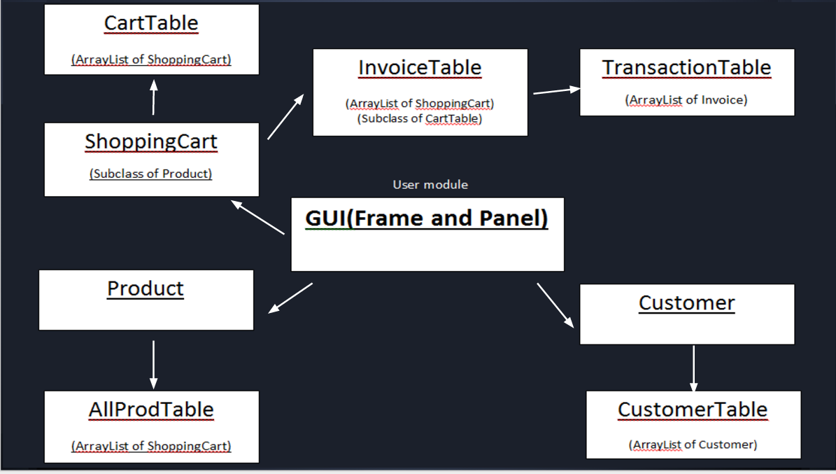

|  |
| --- |
| Customer |
| -loginID:String  -password:String  -FName:String  -LName:String  -nickName:String  -gender:char  -phoneNum:String  -email:String  -DOB:Date  -Age:int  -district:String  -address:String  -discount:float |
| +Customer(inID:String,inPW:String,inFName:String,inLName:String,inGender:char,inEmail:String,inDOB:Date,inPhone:String)  +Customer(inID:String,inPW:String,inFName:String,inLName:String,inNName:String,inGender:char,inEmail:String,inDOB:Date,inPhone:String)  +Customer(inID:String,inPW:String,inFName:String,inLName:String,inGender:char,inEmail:String,inDOB:Date,inPhone:String,inDistrict:String,inAddress:String)  +Customer(inID:String,inPW:String,inFName:String,inLName:String,inNName:String,inGender:char,inEmail:String,inDOB:Date,inPhone:String,inDistrict:String,inAddress:String)  +setNickName(nickName:String)  +serEmail(email:String)  +setDistrict(district:String)  +setAddress(address:String)  +getEmail()l:String  +getDistrict()t:String  +getAddress():String  +setPassword(pw:String)  +setPhoneNum(phoneNum:String)  +setDiscount(discount:float)  +getDOB():Date  +getLoginID():String  +getFName():String  +getLName():String  +getNName():String  +getGender():char  +getPhoneNum():String  +getAge():int  +getDiscount():float  +getPassword():String  -CalculateAge(dateOfBirth:Date):int  +compareTo(otherCus:Customer):Customer |

|  |
| --- |
| Product |
| #productName:String  #productID:String  #description:String  #price:float  #productInv:int  #categories:String |
| +Product(inID:String,inName:String,inCategories:String,inDes:String,inInv:int,inPrice:float)  +getItemName():String  +getproductID():String  +getDescription():String  +getproductInv():int  +getPrice():float  +setProductName(productName:String)  +setCatogories(catogories:String)  +getProductName():String  +getProductID():String  +getProductInv():int  +getCategories():String  +getPrice():int  +getDescription():String  +setProductID(productID:String)  +setPrice(price:float)  +setDescription(description:String)  +setProductInv(productInv:int) |

|  |
| --- |
| ShoppingCart |
| -amout:float  -type:String |
| +ShoppingCart(inSI:boolean,inID:String,inName:String,inCategories:String,inDes:String,inNum:int,inPrice:float)  +setType(type:String)  +getType():String  +setProductInv(newBN:int)  +srtAmount(amount:int)  +getAmount():float |